Advanced Artificial Intelligence
6. Nascent Technologies in AI
6.1 Convergence of AI with Augmented / Virtual reality techniques for product and process development Limitations of 2D Learning Environments, Evolution of virtual worlds and immersive technologies, Definition and concepts of Augmented Reality, Definition and concept of the Metaverse, Characteristics and components of the Metaverse, Challenges andopportunities in the Metaverse ecosystem, AI in the realm of emerging quantum computing paragms
PAST QUESTIONS:
- Explain the limitations of 2D learning environments. (M24, M25)
- What is metaverse? Explain the characteristics and components of the metaverse. (M24, M25)
- Differentiate between Virtual Reality and Augmented Reality. (D24)
- Explain the concept of Metaverse. (D24)

NOTES:

*Limitation of 2D learning environments :-
2D learning environments (e.g., standard web conferences, 2D simulation apps) are limited by a lack of spatial depth, reduced engagement, and poor representation of complex, real-world scenarios. They often lead to passive, monotonous learning experiences that hinder spatial understanding and collaborative interaction compared to 3D virtual spaces.
Key Limitations:
- Spatial and Depth Constraints: 2D systems, such as 2D vision, cannot accurately perceive or model depth, distance, or complex three-dimensional structures.
- Reduced Engagement and Presence: Users often feel disconnected, lacking a sense of shared physical presence in 2D meetings, which leads to lower motivation, passive participation, and higher distraction.
- Limited Interaction Space: Interaction in 2D is limited to the \(x\) and \(y\) axes, restricting the variety of actions and collaborative engagement possible.
- Simplified Representation: 2D environments struggle to capture the complexity of real-world scenarios, making it difficult to transfer learning to practical, hands-on tasks.
- Environmental Sensitivity: 2D systems often require highly controlled lighting and standard views to be effective.
- Poor Social/Emotional Expression: Users often have limited, unnatural ways to communicate emotions compared to in-person interactions.
These limitations suggest that while 2D tools offer high accessibility, they are often less effective than immersive 3D, such as those found on MDPI Metaverse, for training that requires complex spatial reasoning, collaboration, or high realism.

*Metaverse :-
The metaverse is an immersive, shared 3D virtual world where people interact, work, and play through avatars, blending physical and digital realities. It is often described as the "Spatial Internet."
Key Characteristics of the Metaverse
- Persistence: The metaverse does not pause or end. It continues to exist, evolve, and operate in real-time, regardless of whether a user is logged in.
- Immersion & Real-Time Experience: Users feel present in the 3D digital environment, experiencing it as if it were reality through VR headsets, AR glasses, or haptic devices.
- Interoperability: Users can move between different virtual worlds, platforms, or applications seamlessly, taking their digital assets, identities, and currency with them.
- Decentralized Economy: The metaverse supports a fully functioning digital economy, frequently powered by blockchain, cryptocurrency, and NFTs. Users can own, sell, and buy virtual land, goods, and services.
- Social & Interactive (Presence): It allows for real-time social interaction with others. Users are represented by avatars, allowing for communication that mirrors real-world social cues and presence.
- Boundless and Scalable: The digital universe is theoretically infinite, with high scalability to support an increasing number of users, environments, and digital spaces simultaneously.
- User-Generated Content (UGC): Users directly contribute to the creation of the metaverse, building, coding, and designing virtual experiences, spaces, and digital items.
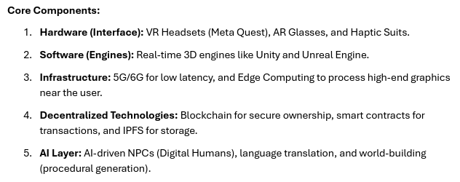

*VR and AR :-
